Smart Device For Women Safety

**S Subashi Vasunthra R S**

Prefinal Year students of Department of Electronics and Communication Engineering

Velammal College of Engineering and Technology, Madurai 625009.

[subashis2003@gmail.com](mailto:subashis2003@gmail.com), [vasunthraswaminathan@gmail.com](mailto:vasunthraswaminathan@gmail.com)

***Abstract:*** In this modern world, women's safety has become a serious concern as they are afraid of physical and sexual abuse and violence once they leave their homes at any instant.The purpose of this device is to safeguard women in the event they might face any danger.This project introduces women's safety through GPS monitoring and alerts via the ARDUINO system, that can be connected to an alarm system and notify the relevant authorities and the saves contacts. The GPS, ARDIUNO receiver, and GSM modem are all used in this messaging system. The suggested idea attempts to create an IoT-based security gadget that relies on women's fingerprints for safety.The switch in the device work for sending manual alerts in case of emergency and as panic switch to get the shock, then the Buzzer will also activate along laser diode.

***Keywords: Women Safety, Emergency, Alerting, Self-defence.***

1. INTRODUCTION

Security is the state of being safe from harm or loss.Security is a concept that is similar to security. The difference between the two is an added emphasis onexterior threat protection. This microcontroller- based system for women's safety. GPS, GSM technology, and a sequence protection system are used to achieve shock-up communication and incident prevention. This article contains security information and software to help women avoid or mitigate hazards. It not only prevents, but also assists women in dealing with challenges.in the past and find appropriate forgiveness and good behavior in society. Existing hand- held devices available for women's safety. After hearing an accident, they require the intervention of women to utilise them, such as pressing a button or repositioning the device. However, if a woman does not have time to open it while she is in danger, the safety device's objective is not fulfilled. In a country like India, where crime is growing faster than the population, burglary is one of the most common crimes, andthe safety of many women is regarded one of the most crucial concerns.

A microprocessor-based system is designed to control a task or a set of tasks, rather than being programmed by the end user like a PC designated as an embedded system. The embedded system is programmed to carry out a specified task with a variety of possibilities. Processing studies, like as a microcontroller or a digital signal processor, are included in the embedded system. Smaller controls are

called "chips," and they can be combined with other sub- controls in a mixed Application Specific Integrated Circuit (ASIC) system. Typically, the input is always from a detector or sensor, and the output is now sent to a trigger that can start or stop the machine's operation.

# LITERATURE SURVEY

The ARM control is used by a security device and an application called FEMME, according to paper [1. It is a true security device created specifically for ladies. Devices can also be purchased or applications can be put on smart phones for emergency access. When someone is depressed, FEMME provides a fast and easy option to reach out for help. The programme is started when pushing the volume up key while simultaneously hitting the power button When the app is first launched, it displays four advanced icons: an audiorecorder, an SOS message, a video recorder, and a hidden camera detection. Sending messages and recording to contacts are set or hidden cameras are found depending on which option is now pressed. Although I activate the device by pressing a button on it, it is connected to a smart phone and has two buttons, one of which is an emergency button and the other of which unlocks a concealed camera adoption.

A portable device, similar to a belt, is proposed in Paper [2]. This device was created after witnessing a few applications and devices, such as VithUapp, which was introduced in conjunction with the popular TV show Gumrah on station [V], and SHE (Society Harnessing Equipment), which produces new technology to assist the victim in escaping, and the founder of ILA security created an alert thatwould startle and disrupt the attackers. The Arduino board, GSM shield, GPS module,screaming alarm, and pressure sensors are all included in this device. The arduino board has everything needed to start a microcontroller, and it may be powered up using a computer, an adapter, or a battery. GSM shield is a compact, low-power device that enables data, voice, SMS, and fax.

The paper [3] suggests a system that includes a wearable safety device with an emergency button to send a notification and a camera to record the attacker's image, allowing the victim's location to be monitored using GPS and a photo to be captured. All responsible contacts will

receive an urgent message with an image link. As a result, the system can better utilise its Arduino-based Linux board. Haversine and Trilateration are not affected by combined algorithms. The fundamental purpose of this programme is to ensure that working women and school children are protected.

The paper [4] proposes a smart security device for a women's programme that incorporates the Raspberry Pi 2, GSM SIM900A, GPS receiver, Live Video streaming, and more functions. Some existing systems have imported these devices, including: VithU App - An emergency app marketed by India's most popular Indian television show "Gumrah," which airs on channel [V]. The stun gun is a small gun that uses electric shock to charge the attacker. It delivers roughly 700,000 volts to the attacker's body. Lithium batteries are used.

# PROPOSED SYSTEM

Two primary GSM devices and a microcontroller appear to be used in this construction. When a client submits a push notifications over GSM, allof the messages are delivered to the controllerusing AT instructions. That microcontroller uses Max232 to collect data in bits, which is then sentto the Lcd screen.

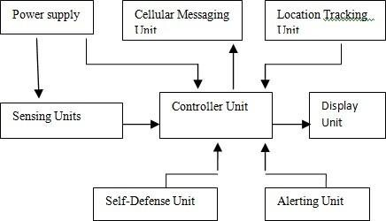

Fig.1 Block Diagram of Women Safety Device Location Tracking Unit

With the support of a Gps device, this equipment downloads the female's present spot. The unit is equipped with 2mm DIP pin adapters for simple module accessibility.

## Mobile Messaging Unit

The GSM user can send the Female's Region and Rescue SMS Service (SMS) to a cops and family. The GSM / GPRS device is used to connect the computer to a GSM-GPRS network. Many nations use the Gps (global positioning system for Cellular (GSM) android - based telecommunications. The GSM / GPRS component is made up of a GSM / GPRS device a power distribution component, and pc ports (such as RS-232, USB, and so on). **Display unit**

The GSM device transmits the female's address andcrisis SMS to the cops and neighbours. TheGSM/GPRS device is used to connect the computer to the GSM-GPRS system. The universal Mobile telecommunications System (GSM) is a system that several countries use for mobile communications.

## Alerting unit

A loud siren and bright lights are a simple, but strong and effective technique to raise an alarm. A powerful LED flash light and an electronic siren are used to accomplish this. When the women's safety gadget detects an emergency

situation involving a woman, it activates its alerting unit, which uses loud noises and bright flashing lightsto notify nearby individuals of the crime.

## Self-Defence Unit

In a circumstance where there are few or no peoplearound, a woman must be able to protect and defend herself while also causing difficultiesfor the abuser. The self-defense unit comprises ofa shock generating gadget that provides an instant electric shock that can immobilise and harm the attacker when employed by the lady.

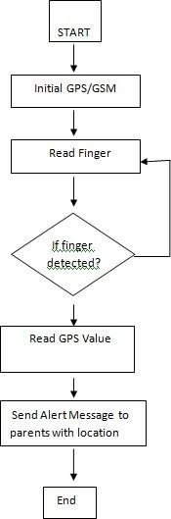

Fig.2 Flow Chart

1. RESULT AND DISCUSSION

This area indicates the latitude and longitude location, which will be delivered to the pre-set contacts with an alert message every 1 minute in a single click. Long pressing the button will dial an emergency number andsend an alarm message to the pre-programmed contact.

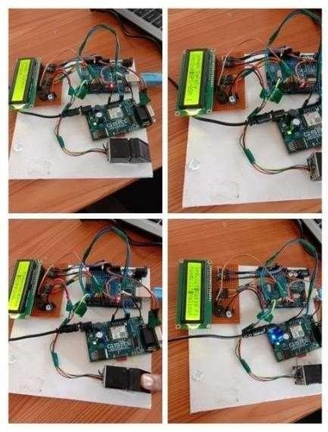

Fig. 3 Actual model of the project

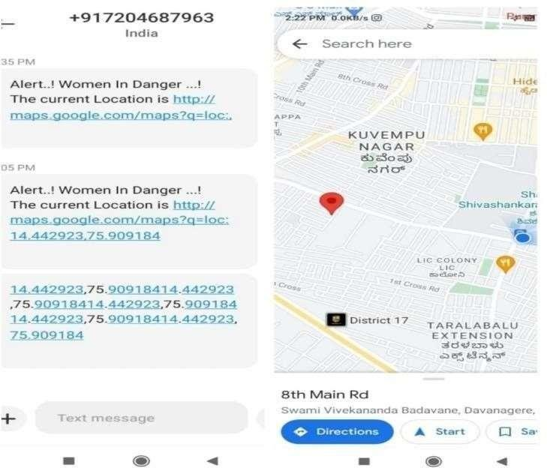

Fig. 4 Message sent to pre-defined number with location

# CONCLUSION

The proposed women's safety equipment aims to provide complete protection for women in today's environment. Individuals are identified by their fingerprints. The user can create a false alarm and ensure that the warning is only triggered during stressful circumstances. To ensure complete security, a buzzer has been installed in the building, allowing anyone around to be alerted to any potentialevent. The victim's current location is texted to the police officers' close relatives. The app user will receive aid right away because this programme finds volunteers at its discretion. The gadget will gain a camera module with video and audio recording capabilities. The camera can provide police with precise information on the attacker. A visible clock and a heart rate monitor will also be included.

REFERENCES

1. Ceccato, V. (2014). The nature of rape places. Journal of environmental psychology, 40, 97-107.
2. Göpfert, M. (2013). Bureaucratic aesthetics: Report writing in the Nigérien gendarmerie. American Ethnologist, 40(2), 324-334.
3. SG, V. (2018). GSM based women’s safety device. International Journal of Pure and Applied Mathematics, 119(15), 915-920.
4. Jain, R. A., Patil, A., Nikam, P., More, S., & Totewar, S. (2017). Women’s safety using IOT. International Research Journal of Engineering and Technology (IRJET), 4(05), 2336-2338.
5. Mazidi, M. A., Mazidi, J. G., & McKinlay, R. D.(2016). The 8051 microcontroller and embedded systems using assembly and C. Rai, P. K., Johari, A., Srivastava, S., & Gupta, P. (2018, December). Design and Implementation of Women Safety Band with switch over methodology using Arduino Uno. In 2018 International Conference on Advanced Computation and Telecommunication (ICACAT) (pp. 1-4). IEEE.
6. Ahir, S., Kapadia, S., Chauhan, J., & Sanghavi, N. (2018, January). The Personal Stun-A Smart Device For Women's Safety. In 2018 International Conference on Smart City and Emerging Technology (ICSCET) (pp. 1- 3). IEEE.
7. Bhilare, P., Mohite, A., Kamble, D., Makode, S., & Kahane, R. (2015). Women employee security system using GPS and GSM based vehicle tracking. International journal for research in emerging science and technology, 2(1), 65-71.
8. Sen, T., Dutta, A., Singh, S., & Kumar, V. N. (2019, June). ProTecht–Implementation of an IoT based 3–Way Women Safety Device. In 2019 3rd International conference on Electronics, Communication and Aerospace Technology (ICECA) (pp. 1377- 1384). IEEE.
9. Kabir, A. T., & Tasneem, T. (2020, June). Safety Solution for women using Smart band and CWS App. In 2020 17th International Conference on Electrical Engineering/Electronics, Computer, Telecommunications and Information Technology (ECTI-CON) (pp. 566-569). IEEE.
10. “Women Safety Device with GPS Alerts using Arduino”, International Journal of Emerging Technologies and Innovative Research Vol. 12, page no. pp777-781
11. Prakash, N., Udayakumar, E., Kumareshan, N., & Gowrishankar,

R. (2021). GSM-based design and implementation of women safety device using Internet of Things. In Intelligence in Big Data Technologies—Beyond the Hype (pp. 169-176). Springer, Singapore.

1. Khanam, S., & Shah, T. (2019, June). Self Defence Device with GSM alert and GPS tracking with fingerprint verification for women safety. In 2019 3rd International conference on Electronics, Communication and Aerospace Technology (ICECA) (pp. 804-808). IEEE.
2. Samhitha, D., Achyuth, B., Aruna, B., Kumar, K. S., & Kedarnath,

H. D. B. (2020). Self Defence Device with GSM Alert and GPS Tracking with Fingerprint Verification for Women Safety.

1. Ranganadh, A. (2020). Women Safety Device with GPS Tracking and Alerts. In Innovations in Electrical and Electronics Engineering (pp. 797-805). Springer, Singapore.